Analysis of AlGaN/GaN-Based MOSHEMT with Different Oxide Layers for RF Applications

Abstract– The analysis of an AlGaN/GaN Metal Oxide Semiconductor High Electron Mobility Transistor(MOSHEMT) structure aims at enhancing Drain characteristics and Radio Frequency performance for high frequency applications. The Drain Characteristic performance parameters such as threshold voltage, drain current, and transconductance are evaluated along with the radio frequency metrics namely, cutoff frequency and maximum oscillating frequency. An oxide layer is used over gate terminal to reduce electrical leakage while maintaining a fast and efficient flow of electrons in the channel formed between Aluminium Gallium Nitride (AlGaN) and Gallium Nitride (GaN) layers. The device compared four different oxide materials with different dielectric constant for better performance namely, Silicon dioxide (Sio2), Aluminium Oxide (Al2O3), Zirconium Oxide (ZrO2) and Hafnium Oxide (HfO2). For the simulation, silicon dioxide is used as oxide material with dielectric constant 3.9 and a thickness of 4 nano meters. As a result, thicker oxide reduces tunneling current but simultaneously decreases gate capacitance which leads to weakening channel control. To overcome this limitation, the incorporation of high-k dielectrics is considered without compromising capacitance Simulation outcomes demonstrate a drain current of 0.259 A, a cutoff frequency of 24 GHz, and a maximum oscillating frequency of 47 GHz. These findings highlight the potential of proposed MOSHEMT structure for advanced RF and microwave systems, including communication and Radar applications.
Keywords — AlGaN/GaN MOSHEMT, High Electron Mobility Transistor (HEMT), High-k dielectric, Gate oxide, Drain characteristics, Transconductance, Cutoff frequency, Maximum oscillation frequency, RF and microwave applications.

- INTRODUCTION

The research into wide bandgap semiconductor was led by the growing demand of high-frequency and high-power devices particularly on Gallium Nitride (GaN) and Aluminium Gallium Nitride (AlGaN) which are in heterojunction. These materials demonstrate wide bandgap energy, strong polarization-induced electric fields. The properties of AlGaN/GaN heterostructures such as formation of the high-density two-dimensional electron gas (2DEG) channel result in Radio Frequency, microwave power amplifiers and next-generation high-voltage applications.

MOSHEMTs are the combination of High Electron Mobility Transistor (HEMTs) and Metal Oxide Semiconductor Field Effect Transistor (MOSFETs) where HEMTs have high electron mobility, high-frequency performance, efficiency and scalability towards millimeter-wave applications due to 2DEG utilization. Their main drawback is gate leakage due to Schottky gate design, which worsens under high voltage or temperature degrading noise performance.

To address these limitations, a thin oxide layer is used between gate terminal and AlGaN barrier leading to Metal Oxide Semiconductor High Electron Mobility Transistor (MOSHEMT) which maintains the advantage of HEMTs and reduce leakage. This structure combines gate control with high frequency and power benefits for next-generation applications.
The drain characteristic parameters like threshold voltage, drain current, and transconductance are improved by evaluating along with Radio frequency indicators namely, cutoff frequency and Maximum oscillating frequency. The oxide layer plays a key role since tunneling current and leakage suppression are governed by gate dielectric. High-k dielectrics balance oxide thickness with capacitance density leading to enhanced performance and reliability. MOSHEMT compares four different oxide materials with different dielectric constant for better performance namely, Silicon dioxide (Sio2), Aluminium Oxide (Al2O3), Zirconium Oxide (ZrO2) and Hafnium Oxide (HfO2).
As a result, Silicon oxide of dielectric constant 3.9 and thickness 4nm is used for simulation. The simulation yields a drain current of 0.259 A, cutoff frequency, maximum oscillating frequency of 24GHz and 47GHz respectively. It exhibits strong gate control and low leakage. Silicon dioxide is further advantageous for thermal stability, and low defect density. Hence, it is suitable for AlGaN/GaN MOSHEMTs.

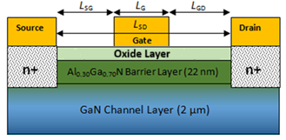
Figure 1: Structure of Proposed MOSHEMT

- LITERATURE SURVEY
N. Islam et al. [1] evaluated the depleting mode operation of AlGaN/GaN phonon-mediated MOSHET using simulation by investigating and evaluating various parameters, which include 2DEG density with temperature, threshold voltage with temperature, transconductance with temperature, and drain current with temperature.
Mohammad Abdul Alim et al. [2] An experiment on the variation of DC and RF transconductance of GaAs single-heterojunction (HJs) and (double) heterojunction (DHJs) high electron mobility transistors (HEMTs), and GaN HEMTs for different temperatures ranging from 40° to 150°C. The paper explained that a bias operation point exists with zero temperature coefficient for GaAs devices and how it enables operation of these devices with stability and temperature, and would help in designing these devices for bias stability.
Yu Zhang et al. [3] This research was done on one of the applications of minority carriers for GaN MOSHEMTs with high-k ZrO2 gate insulators. They were able to determine that there was a minimum shift of threshold voltage under stress of −0.31 V and a dynamic ON-resistance ratio at a minimum of 2.05. This showed very stable materials for the insulators. This information was also helpful in understanding the charge trapping mechanisms involved in the emission and capture processes, thereby determining the reliability and degradation mechanisms of MOSHEMTs.
Yu Zhang et al. [4] documented the introduction of a 5nm in-situ SiNx dielectric layer into GaN MOSHEMTs, which resulted in good dynamic stability and lower charge trapping during both pulsed and bias stress conditions. Jie Li et al. [5] This model allows for solving heat conduction in existing HEMTs of complicated geometries through simplification and makes it possible to use accurate capabilities for predicting channel temperature, thermal resistance, and inter-finger coupling, all of them taking into account variations of thermal conductivity due to its temperature and anisotropy dependences.
Ajay Kumar Visvkarma et al. [6] examined the changes to various properties of AlGaN/GaN HEMTs due to exposure to gamma radiation. The tests showed that contact resistance was reduced after the metal-to- semiconductor interface improved, which led to enhanced transport of charge carriers and reduced scattering.
Rajrup Mitra et al. [7] have proposed some interesting features of the symmetric underlap engineering of double-gate AlGaN/GaN MOS-HEMT devices, which control the electric field distribution with equally recessed gate regions from the source and drain region, resulting in reduced short-channel effects, reduced field crowding, and enhanced power conversion efficiencies with reduced parasitic capacitance and DIBL. Ching-Ting Lee et al. [8] A fin-gated AlGaN/GaN MOSHEMT structure was developed that can offer improved electrostatic control of the channel and reduced effects of short channels. This fin-gated structure will enable the gate to more closely wrap around the channel/fin, leading to improved electric field control of the channel, improved uniformity in current flow, and reduced gate leakage. This MOSHEMT structure will enable improved high-frequency performance through the reduction of parasitic capacitances and improvement in transconductance and cut-off frequency, while simultaneously reducing the noise figure, which is a critical parameter in RF front-end and low-noise amplifier design.
Fabian Thome et al. [9] developed 20-nm InGaAs MOSHEMT-based low-noise amplifiers, which are optimized for (75–110 GHz) applications on both GaAs and silicon substrates. K Takakura et al. [10]. found that Gate lengths and orientations were studied in combination with GaN/AlGaN MOSHEMT devices to characterize the effect of device trapping on low-frequency noise. Shorter gate lengths produce an increase in both G-R and 1/f noise due to a higher frequency of carrier interaction with interface traps compared to longer gate lengths.

- SYSTEM DESIGN AND METHODOLOGY

The workflow of the AlGaN/GaN MOSHEMT-based system is illustrated in Fig 2. First, a literature survey was conducted. Then, structural selection was conducted to select the required materials and oxides for the system. After that, the process of meshing and doping was defined to accurately simulate the system. The DC and RF physical model were used to accurately calculate the required parameters like ID, gm, ft, and fmax. Finally, the results were optimized to assess which dielectric offers better performance at high frequencies.
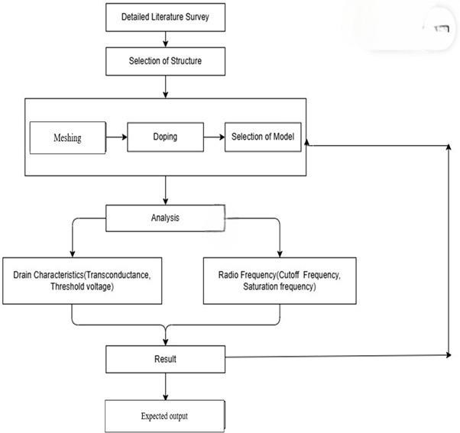
Figure 2: Flowchart of the proposed methodology for AlGaN/GaN MOSHEMT

A. Detailed Literature Survey
A thorough literature search constitutes the first phase of this research, during which the existing research on the performance of HEMT, MOSFET, and MOSHEMT device models will be thoroughly examined. During this phase, the design, operating principles, and performance limitations of these devices will be examined. By examining the features of various models of these devices, including those made of different materials, the major problems associated with these models, as well as the advantages and disadvantages, can be identified.
B. Structure Selection
Based on what has been learnt through the reading process, the best configuration of the MOSHEMT will be determined based on the best information that can be obtained from the research, with the structure defined to include: the composition of the material, the thickness of the layers, and the nature of the interface (source, drain, gate, and the region of the channel) defined in a way that ensures the efficiency of carrier movement with minimal gate leakage.
C. Doping Definition
Doping levels are defined in order to identify the kinds of charge carriers present and their concentration in different regions of the device. This is very important information for determining the impact of these characteristics on the device. The width of the gate, mobility of the carriers, and drain current are influenced by defined doping levels.
D. Analysis Phase
Once the structures and models are defined, an analysis phase will be carried out in order to analyze the electrical and frequency performance of the MOSHEMT. The MOSHEMT will be simulated under different bias conditions in order to obtain its DC and RF characteristics.

E. Drain Characteristics Evaluation
To extract critical parameters like trans-conductance (gₘ) and threshold voltage (Vth), drain characteristics are analyzed for current-driving capacity and switching efficiency.
F. Radio Frequency Analysis
In radio frequency evaluations, the analysis entails the critical parameters measured to obtain the cutoff frequency (ft), maximum oscillation frequency (fmax), and the evaluation of the performance of each test to assist in assessing the performance of RF devices for microwave and millimeter waves.
G. Result Evaluation
Once all of the simulations done on different materials of oxides are complete, it is analyzed and compared what extent each of these different materials of oxides can affect performance characteristics such as drain current, threshold voltage, cutoff frequency, fmax, etc., and which of these materials of oxides can produce the best combination of material and dielectric for optimum device performance.
H. Expected Output
The results expected to be obtained for MOSHEMT design show that there will be significant improvements in terms of performance by optimizing the supply of MOSHEMTs. The results obtained through simulation have been compared with known literature and theoretical values to show improvements in terms of transconductance, frequency response, and stability of threshold voltage, as well as gate leakage values compared with previously reported values.

SIMULATION RESULTS AND DISCUSSION
The simulation of the AlGaN/GaN-based MOSHEMT was successfully carried out using the Silvaco ATLAS tool to analyze both DC and RF characteristics of the device. During the analysis, more than three oxide layers were evaluated to study their dielectric constants, gate leakage behaviour, and interface properties. Based on comparative results, the most suitable oxide material was selected to achieve optimal device performance and stability. The drain current variations were recorded and analysed by applying a constant drain bias and gliding the gate voltage from negative to positive values to observe the device’s output response. The simulation of the AlGaN/GaN-based MOSHEMT was successfully carried out using the Silvaco ATLAS tool. During the analysis, more than three oxide layers with oxide thickness of 1nm, 2nm and 4nm were evaluated to study their dielectric constants, gate leakage behavior, and interface properties. Based on comparative results, the most suitable oxide material was selected to achieve optimal device performance and stability. By applying a constant drain bias and sweeping the gate voltage from negative to positive values, the drain current variations were recorded and analyzed to observe the device’s output response. The different semiconductor oxide layers are listed along with the obtained result for 1nm, 2nm and 4nm.

A. Zirconium Dioxide (ZrO2) - 1nm
Zirconium dioxide has high dielectric constant, excellent thermal stability, and strong resistance to gate leakage. The dielectric constant of Zirconium dioxide (ZrO2) is 29. This oxide layer improves the gate control and overall device performance. They were analyzed with different oxide thickness to achieve the objective of MOSHEMTs. This oxide layer was placed on AlGaN barrier, and GaN channel region, ensuring accurate modeling of material behaviour. They were first analyzed with a thickness of 1 nm.

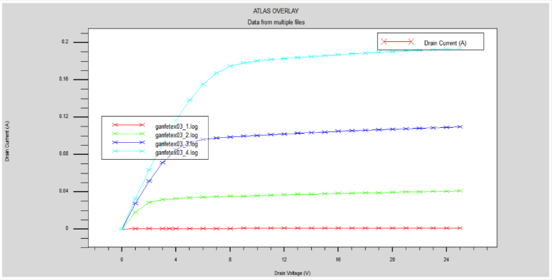
Figure 3b: Output characteristics curve of 1nm ZrO2
Figure 3b. shows the drain characteristics of the GaN-based MOSHEMT, depicting the variation of drain current (Iᴅ) with drain voltage (Vᴅ) for different gate voltages (Vɢ). The drain current increases linearly at low voltages (ohmic region) and saturates at higher voltages (saturation region). With increasing gate voltage, the drain current rises, indicating strong gate control and efficient carrier transport, confirming the device’s suitability for high-power and high-frequency applications.
Figure 3c illustrates the transfer characteristics of the GaN-based MOSHEMT, depicting the relationship between the drain current (Iᴅ) and the gate-to-source voltage (Vɢ). The channel remains depleted at highly negative gate voltages and due to the absence of sufficient carriers, drain current is minimal. As the gate voltage is increased toward the threshold voltage, the electric field across the gate oxide-semiconductor interface becomes so strong that it pushes more electrons into the channel, leading to the formation of a conducting channel, which starts to conduct. Beyond the value of threshold voltage, a rapid increase of the drain current
The steep transition of this curve is indicative of an enhancement-mode device, where the current starts flowing once the gate voltage overcomes the threshold voltage, thus maintaining low off-state leakage, and superior switching characteristics. A good smooth, well defined curve points at efficient gate modulation, no hysteresis, and good interface between oxide and semiconductor. So the GaN MOS-HEMT is very promising for high-speed as well as high-frequency application where tight control of the current, low leakages, fast switching are important for high efficiency device characteristics. Similar analysis is to be done for 4 nm layer.

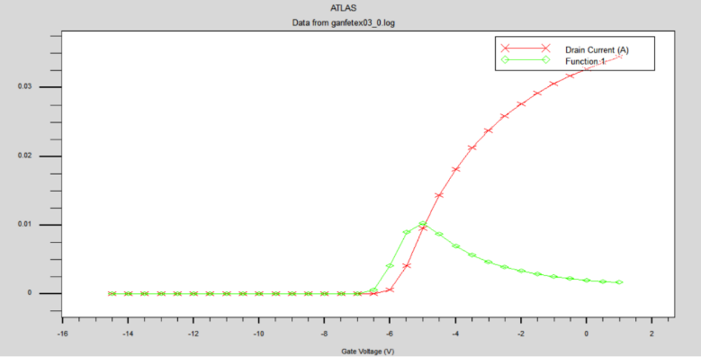
Figure 3c: Transfer characteristics curve of 1nm ZrO2
B. Hafnium Dioxide (HfO2) – 1 nm
Hafnium dioxide has a high dielectric constant, good thermal stability, and strong resistance to gate leakage. The dielectric constant of hafnium dioxide is about 25. Its inclusion enhances gate insulation and reduces leakage current, thus boosting the overall electrical characteristics performance of MOSHEMTs. Different oxide thicknesses were investigated to improve performance of the device and enhance the control of the channel's conductivity. The HfO₂ cap was put on top of AlGaN barrier layer in order to model the properties between bulk and interfacial materials. They were firstly inspected at an thickness of 1 nm.
This simulated MOSHTEM structure comprises several components: a gallium nitride core region, aluminium gallium nitride shielding material, hafnium dioxide dielectric insulation, and silicon nitride surface protection. Layered materials improve gate insulation by enhancing it; simultaneously, silicon nitride mitigates surface defects for stable operation demonstrated in Figure 4A. Conductor segments denote the input node, anode, and cathode positions, facilitating smooth electrical conduction. The engineered layout offers robust static electrical management, heightened current flow through channels, and significantly boosted comprehensive system functionality.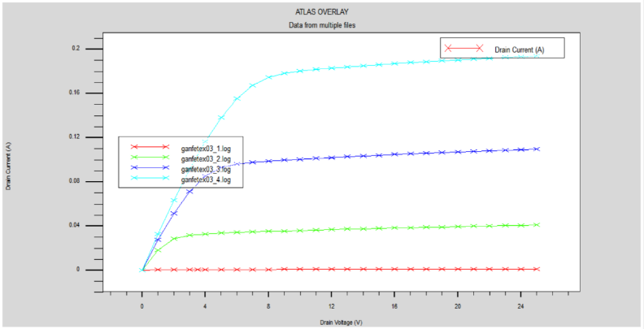
Figure 4: Output characteristics curve of 1nm HfO2
Figure 4B illustrates the properties of the output. Demonstrate how variations in drain current occur depending on changes in drain voltage across various gate voltages. Curves reveal an initially steady rise in concentration leading into a plateau phase, signifying successful channel development and pinching off mechanisms at play. With an increase in gate voltage, the drain current escalates as well, illustrating successful gate manipulation and robust drain management capabilities. Significant enhancements in current handling capacity and operational efficacy have been observed due to elevated levels of HfO2 as a dielectric material.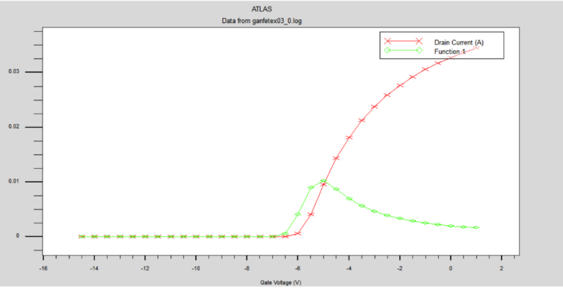
Figure 4c: Transfer characteristics curve of 1nm HfO2
Figure 4C illustrates how drain current varies with gate voltage; it emphasizes both the threshold voltage and the transconductance properties exhibited by the component. An abrupt increase above the critical voltage signifies effective channel development and robust gate manipulation. In this under-voltage area, there is virtually no current flow, which validates the exceptional insulation properties of hafnium oxide. Near the threshold, high peak transconductance boosts switching efficiency; this verifies that the MOSHEMT configuration offers enhanced durability while minimizing gate current leaks. Consequently, every examination conducted at a four-nanometer layer size is similarly applicable.
C. Aluminium Dioxide (Al2O3) – 4nm
The Aluminium oxide (Al2O3) is characterised by its moderately low dielectric constant, remarkable thermodynamic durability and formidable barrier against transistor shorts. The dielectric constant of Al2O3 is approximately 9. It decreasing electrical flow , thus enhancing the system’s stability and efficiency for use in MOSFET technologies. Various oxide layer widths were studied for optimal performance in terms of conductivity and effective management of charge carriers within the semiconductor region. An Al2O3 coating lay in between an AlGaN insulating shield and a GaN conducting zone for precise simulation of materials' behaviour at interfaces.
Aluminium Oxide is simulated with 4nm thickness acts as an insulator on Gallium Nitride (GaN) and Aluminium Gallium Nitride (AlGaN) which are base material and buffer zone respectively. Layered aluminium oxide serves as an efficient insulation agent due to its high thermal durability and low dielectric conductivity at approximately nine units, significantly reducing transistor current flow while improving signal modulation efficiency. The silicon nitride barrier coating minimizes surface imperfections and enhances performance by marking the transistor's control elements: its gate terminal, source contact, and drain connection points.
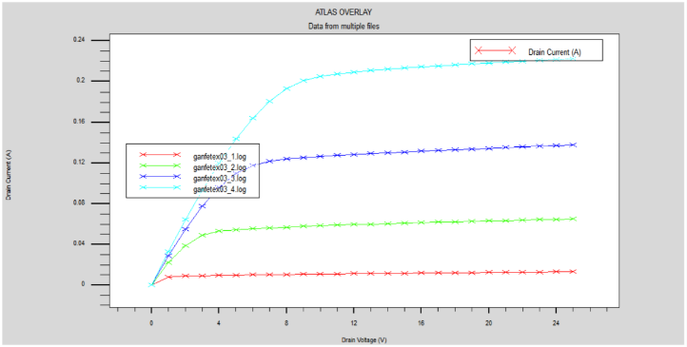
Figure 5: Output characteristics curve of 4nm Al2O3

The data points associated with the 4-nanometer thickness of aluminium oxide reveal how the drain current varies with respect to the drain voltage as influenced by different gate voltages, offering insights into the operation mode and behaviour of the Metal-Oxide-Semiconductor Field-Effect Transistor configuration. At first, when the input voltage is minimal, the output current grows proportionally as per Ohm's law due to direct relationship between voltage and flow of electrons within the component. With each rise in drain voltage, the graphs transition into the saturated area, at which point the flow remains almost steady, signifying the beginning of pinch-off along with the establishment of a persistent channel. Clear delineation of movement across the linearity and cutoff areas substantiates successful signal transmission and robust current management, both vital for maintaining component integrity and predictable performance outcomes. As the gate voltage rises, there's an observable increase in drain current, highlighting effective gate manipulation through the use of the Al2O3 insulating material. The behavior underscores Al2O3's capacity for sustaining effective electrical insulation without causing significant current flow through its gates. In comparison to materials such as hafnia oxide (HfO2) or zirconia oxide (ZrO2), aluminum oxide layers exhibit an intermediate drain current level, highlighting a balance between transconductance enhancement and reduction in leakage effects.
The oxide’s moderate dielectric constant contributes to a balanced performance providing sufficient current drive without compromising leakage reduction. Compared to higher-k oxides like HfO₂ or ZrO₂, the Al₂O₃ layer delivers a moderate drain current, reflecting a trade-off between transconductance and leakage suppression. Overall, these characteristics suggest that Al₂O₃ offers a stable and reliable gate dielectric solution, ensuring consistent performance with reduced power dissipation, making it a suitable choice for medium-power and high-frequency MOSHEMT applications.
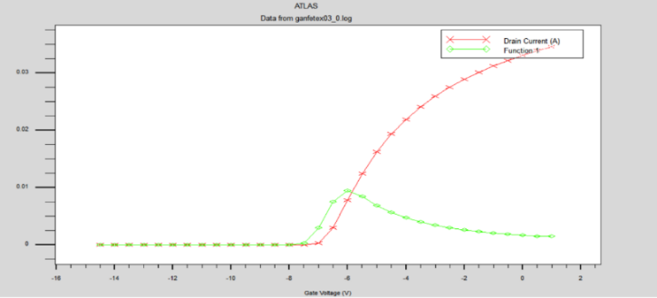
Figure 5c: Transfer characteristics curve of 4nm Al2O3
The transfer characteristics depict the variation of drain current with gate voltage, demonstrating threshold behavior and transconductance trends. A sharp increase in current after the threshold voltage indicates efficient channel formation, while the subthreshold region confirms low gate leakage due to the insulating nature of Al₂O₃. The transconductance peak near the threshold reflects good gate modulation and switching capability. Overall, the 4 nm Al₂O₃ oxide layer ensures stable operation, reduced leakage, and reliable performance in MOSHEMT devices. Furthermore, the smooth current transition across different gate voltages indicates minimal interface trap effects and superior oxide–semiconductor compatibility. This enhances the overall device linearity and makes the structure well-suited for high-frequency and analog circuit applications.
D. Silicon Dioxide (SiO2) – 1nm
Silicon dioxide (SiO₂) is widely recognized for its excellent insulating properties, strong thermal stability, and compatibility with semiconductor fabrication processes. With a dielectric constant of approximately 3.9, SiO₂ provides effective gate insulation and minimizes leakage current, though its relatively low dielectric value can limit gate capacitance compared to high-k materials. Incorporating SiO₂ in MOSHEMT structures ensures stable operation, reduced interface states, and improved reliability under high electric fields. Different oxide thicknesses were examined to optimize gate control and achieve balanced performance between insulation quality and current conduction. The SiO₂ layer was strategically positioned between the AlGaN barrier and the GaN channel region to ensure accurate simulation of material interfaces and electrical characteristics.
The simulated MOSHEMT structure with a 1 nm SiO₂ dielectric layer comprises a GaN channel, an AlGaN barrier, and a thin SiO₂ insulating layer. The SiO₂ layer, with its dielectric constant of approximately 3.9, provides excellent insulation and strong thermal stability, though its lower dielectric value compared to high-k oxides slightly limits gate capacitance as shown in figure 6a. The Si₃N₄ passivation layer minimizes surface defects and enhances overall device reliability. Metallic contacts represent the gate, source, and drain terminals, ensuring efficient electron flow through the device. This structure ensures effective isolation with controlled leakage behavior and stable operation.
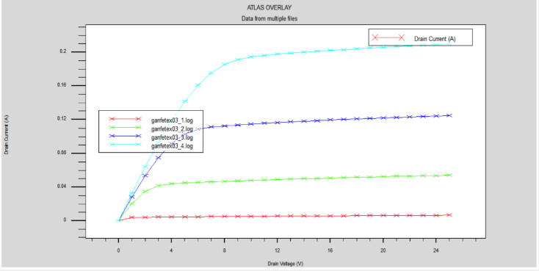
Figure 6b: Output characteristics curve of 1nm SiO2
The output characteristics for the 1 nm SiO₂ layer depict the variation of drain current with drain voltage at different gate voltages. The graph shown in figure 6 exhibits a clear linear and saturation region, indicating proper channel formation and controlled current conduction. As gate voltage increases, drain current rises steadily, confirming efficient gate modulation. Nevertheless, owing to SiO2's minimal dielectric constant, its present driving force remains marginally less than those in higher k oxide materials. Such conduct signifies dependable performance with negligible leaks and well-regulated drainage controls.
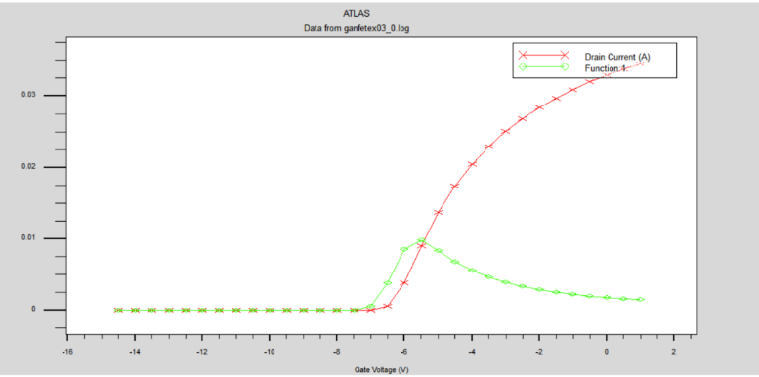
Figure 6c: Transfer characteristics curve of 4nm SiO2
The transfer characteristics shown in figure 8c illustrate the relationship between drain current and gate voltage showing a distinct threshold voltage where current rapidly increases. The subthreshold region displays minimal current, confirming good gate insulation and low leakage. The transconductance peak near the threshold voltage indicates strong gate control and efficient switching. The 1 nm SiO₂ layer thus provides reliable insulation, stable electrical behavior, and consistent device performance suitable for precise modeling and analysis in MOSHEMT applications. Similarly, all analysis done for 4 nm thickness also.
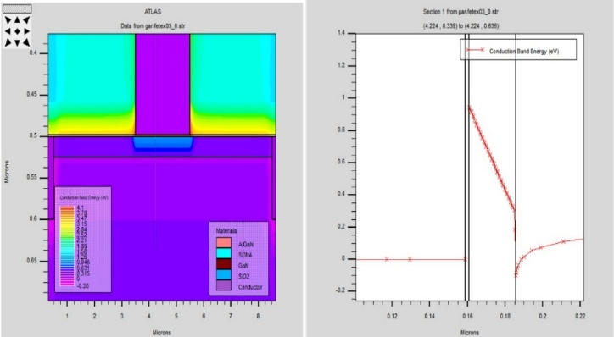
Figure 6d: Energy Band Diagram and Device Electric Field
A detailed examination of the electrical properties within an aluminum gallium nitride/gallium nitride metal-oxide-semiconductor high-electron-mobility transistor architecture featuring a four-nanometer silicon dioxide insulating barrier reveals critical information about the electric field strength and how carriers are confined inside this component illustrated by Figure 6D. A notable shift occurs along the boundary between aluminum gallium nitride and nitrogen-doped gallium nitride, revealing an abundance of electrons confined within a thin layer parallel to the surface, indicating the creation of a dense two-dimensional electronic state there. In this area, it is crucial for improving electron movement speed and boosting electrical power output significantly. Introducing an interlayer composed of silicon dioxide situated between the gate conductor and aluminum gallium nitride serves to enhance insulating properties around the transistor's gate region, thereby mitigating current flow through it without compromising precise modulation of charge carriers within the active area. A gradual shift in electron mobility around the junction suggests few impurities present there, crucial for optimal current flow and durable electronic components operation.
A detailed depiction of the one-dimensional conductivity band distribution across the gate line is evident on the accompanying graph; this visualization substantiates the existence of an apparent depletion region near the boundary between aluminum gallium nitride and gallium nitrogen-doped gallium nitride. The prospective well reflects the robust electron containment characteristic found in highly efficient High Electron Mobility Transistor configurations. A thin silicon dioxide insulating film acts as an isolation mechanism between the gate conductor and the active semiconductor area, allowing for controlled adjustment of electrical potentials within this zone without disrupting its functionality. This equilibrium guarantees minimal gate current flow and enhanced transistor performance characteristics, crucial for dependable operations at both high frequencies and power levels. Furthermore, the lowest point in the conducting band coincides perfectly at the spot where the two-dimensional electron gas is found, thus validating successful quantization of charge carriers and boosting their conductive properties significantly.
For every oxide layer examined along with its corresponding thickness, the simulated electrical properties have been compiled into this table. Parameters assessed encompass gm for transconductance, ft at cutoff frequency, fmax up to maximum frequency, Id in drain current, and Vth as threshold voltage. The specified criteria offer an in-depth insight into how various dielectrics affect the total functionality and resonant characteristics of the MOSHEMT circuit component.

Table 1: Comparison table of proposed device with different oxide layers. 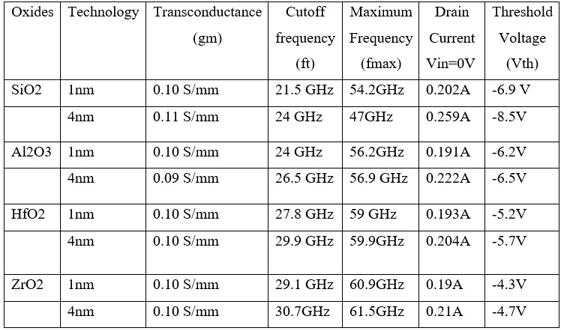

- CONCLUSION
The AlGaN/GaN-based MOSHEMT provides MOSFETs with both reduced gate leakage and high gate controllability as well as the HEMTs with impressive electron mobility and high saturation velocity. It enables the drain current ability as well as the transconductance and overall device linearity, leading to superior RF performance and enhanced power efficiency. The MOSHEMT achieves tighter electrostatic control along with reduced interface trap density and enhanced stability of the threshold voltage through precise engineering of oxide thickness along with dielectric material optimization and heterostructure design enhancement. Utilizing dielectrics such as HfO₂ or ZrO₂ as high-k materials to minimize gate leakage while improving capacitance and device stability. These materials also enable more effective gate control and improved high-frequency performance. Such dielectrics provide superior dielectric strength to reduce power consumption and also provide high reliability in both high temperature and high power applications. A MOSHEMT with the recent developments described in this dissertation can also be fabricated for integration into future mobile communication modules (5G/6G), as well as in radar systems and satellite transceivers. Given its excellent combination of high power density and frequency performance, the developed device offers great promise for miniature and low power RF front end applications.
REFERENCES
[1] N. Islam, M. F. A Packeer Mohamed, N Ahmad, M Mohamad isa, A F. Abd Rahim, and K. Ahmeda, “Analytical modeling of depletion-mode moshemt device for high- temperature applications,” IEEE Access, vol.12, pp. 36447-36456,2024.
[2] Mohammad Abdul Alim, Anwar Jarndal , Christophe Gaquiere , Giovanni Crupi, “A study of DC and RF transconductance for different technologies of HEMT at low and high temperatures” J Mater Sci: Mater Electron, Springer, vol.34, pp. 1-12,2023.
[3] Yu Zhang, Yitian Gu, J. Chen, Y. Zhu, B. Chen, H. Jiang, “Small v_{th} shift and low dynamic r_{on} in gan moshemt with zro₂ gate dielectric,” IEEE trans, vol.70, no. 11, pp. 5590- 5595,2023.
[4] Yu Zhang,Lihuaxu, Yitian gu, Haowenguo, Huaxing jiang, Kei may lau, “Dynamic Characteristics of GaN MISHEMT With 5-nm In-Situ SiNx Dielectric Layer,” IEEE J. Electron Devices Soc., vol. 10, pp. 540–546, 2022.
[5] Jie Li, Min Tang and Junfa Mao, Fellow, “Analytical Thermal Model for AlGaN/GaN HEMTs Using Conformal Mapping Method” IEEE Trans. Electron devices, vol. 69, no. 5,2022.
[6] Ajay Kumar Visvkarma, Khushwant Sehra, Graduate Student Member, IEEE, Chanchal, Robert Laishram, Amit Malik, Sunil Sharma, “Impact of Gamma Radiations on Static, Pulsed I–V, and RF Performance Parameters of AlGaN/GaN HEMT,” IEEE Trans. Electron Devices, vol. 69, no. 5, 2022.
[7] Rajrup Mitra, Akash Roy, Arnab Mondal, Atanu Kundu , “Influence of Symmetric Underlap on Analog, RF and Power Applications for DG AlGaN/GaN MOS-HEMT,” Silicon Volume 14, pages 2329–2336 (2022)
[8] Ching-Ting Lee, Life Fellow, Jia-Chen Guo, “Fin-Gated Nanochannel Array Gate-Recessed AlGaN/GaN Metal-Oxide-Semiconductor High-Electron-Mobility Transistors,” IEEE Trans. electron devices, vol. 67, No. 5, may 2020.
[9] Fabian Thome, Felix Heinz, Arnulf Leuther, “InGaAs MOSHEMT W-Band LNAs on Silicon and Gallium Arsenide Substrates” IEEE Microwave and Wireless Components Letters, Volume 30, Issue 11 ,PP.1089–1092, 2020.
[10] K. Takakura, V. Putcha, E. Simoen, A. R. Alian, U. Peralagu, N. Waldron, B. Parvais and N. Collaert, “Low-Frequency Noise Investigation of GaN/AlGaN Metal–Oxide–Semiconductor High-Electron-Mobility Field-Effect Transistor With Different Gate Length and Orientation,” IEEE Trans. Electron Devices, vol. 67, no. 8, 2020.

